Experiment 2

Name : Yash Liladhar Amarapurkar

Class : TY CSE Div: A Roll No:41

Border Layout:

import java.awt.\*;

class bdlyt extends Frame {

bdlyt() {

setSize(600, 600);

setVisible(true);

setTitle("The Frame Layout Code");

setLocation(700, 350);

BorderLayout bl = new BorderLayout(20, 20);

Button b1 = new Button("Save");

add(b1, bl.NORTH);

Button b2 = new Button("Clear");

add(b2, bl.SOUTH);

Button b3 = new Button("Cancel");

add(b3, bl.EAST);

Button b4 = new Button("Submit");

add(b4, bl.WEST);

Label l = new Label("Welcome to Advance Java", Label.CENTER);

add(l, bl.CENTER);

}

public static void main(String args[]) {

new bdlyt();

}

}

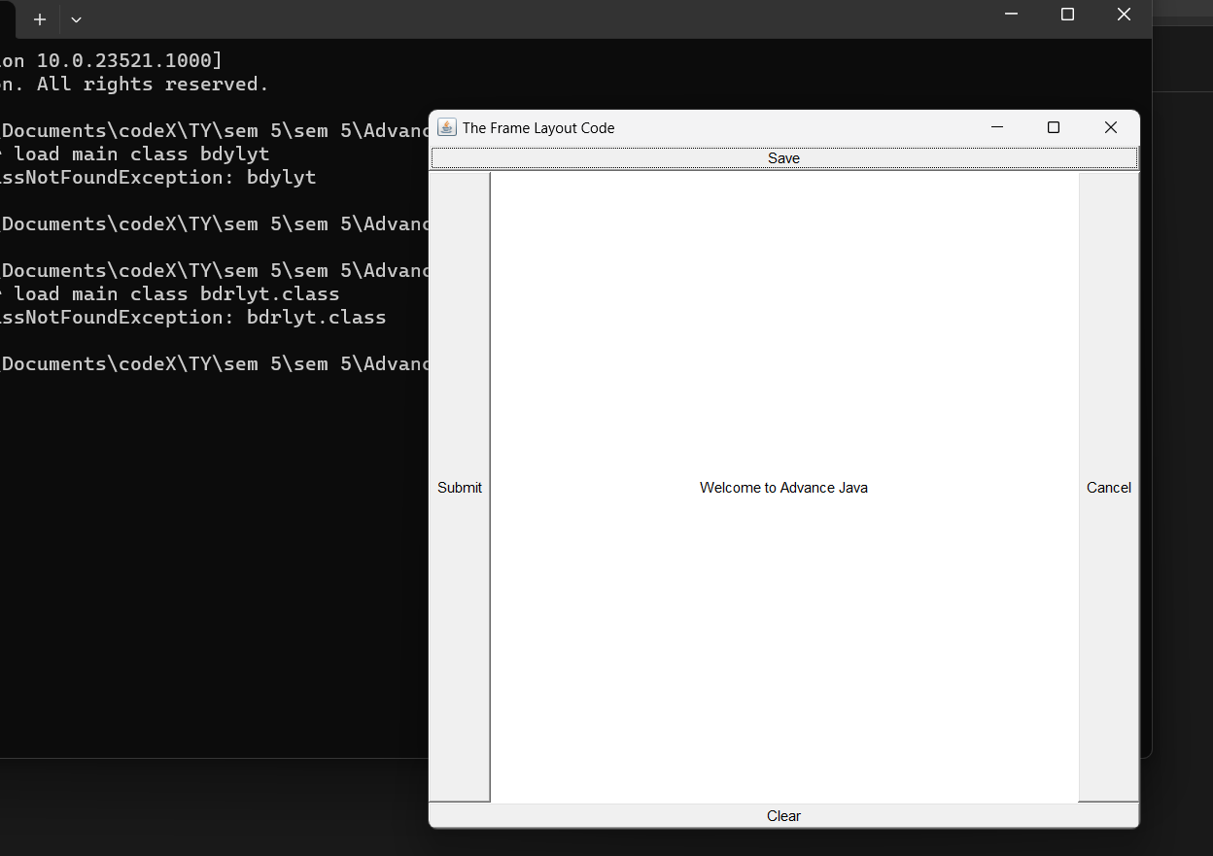

Grid Layout:

import java.awt.\*;

class grdlyt extends Frame {

grdlyt() {

setVisible(true);

setSize(500, 500);

setTitle("Example of Grid Layout");

GridLayout gl = new GridLayout(5, 5);

Label ll = new Label("Name : ");

add(ll);

TextField name = new TextField();

add(name);

Label l = new Label("Username : ");

add(l);

TextField user = new TextField();

add(user);

Label ll1 = new Label("Email : ");

add(ll1);

TextField email = new TextField();

add(email);

Label l1 = new Label("Password : ");

add(l1);

TextField pass = new TextField();

pass.setEchoChar('@');

add(pass);

Button b = new Button("SUBMIT");

add(b);

setLayout(gl);

}

public static void main(String args[]) {

new grdlyt();

}

}

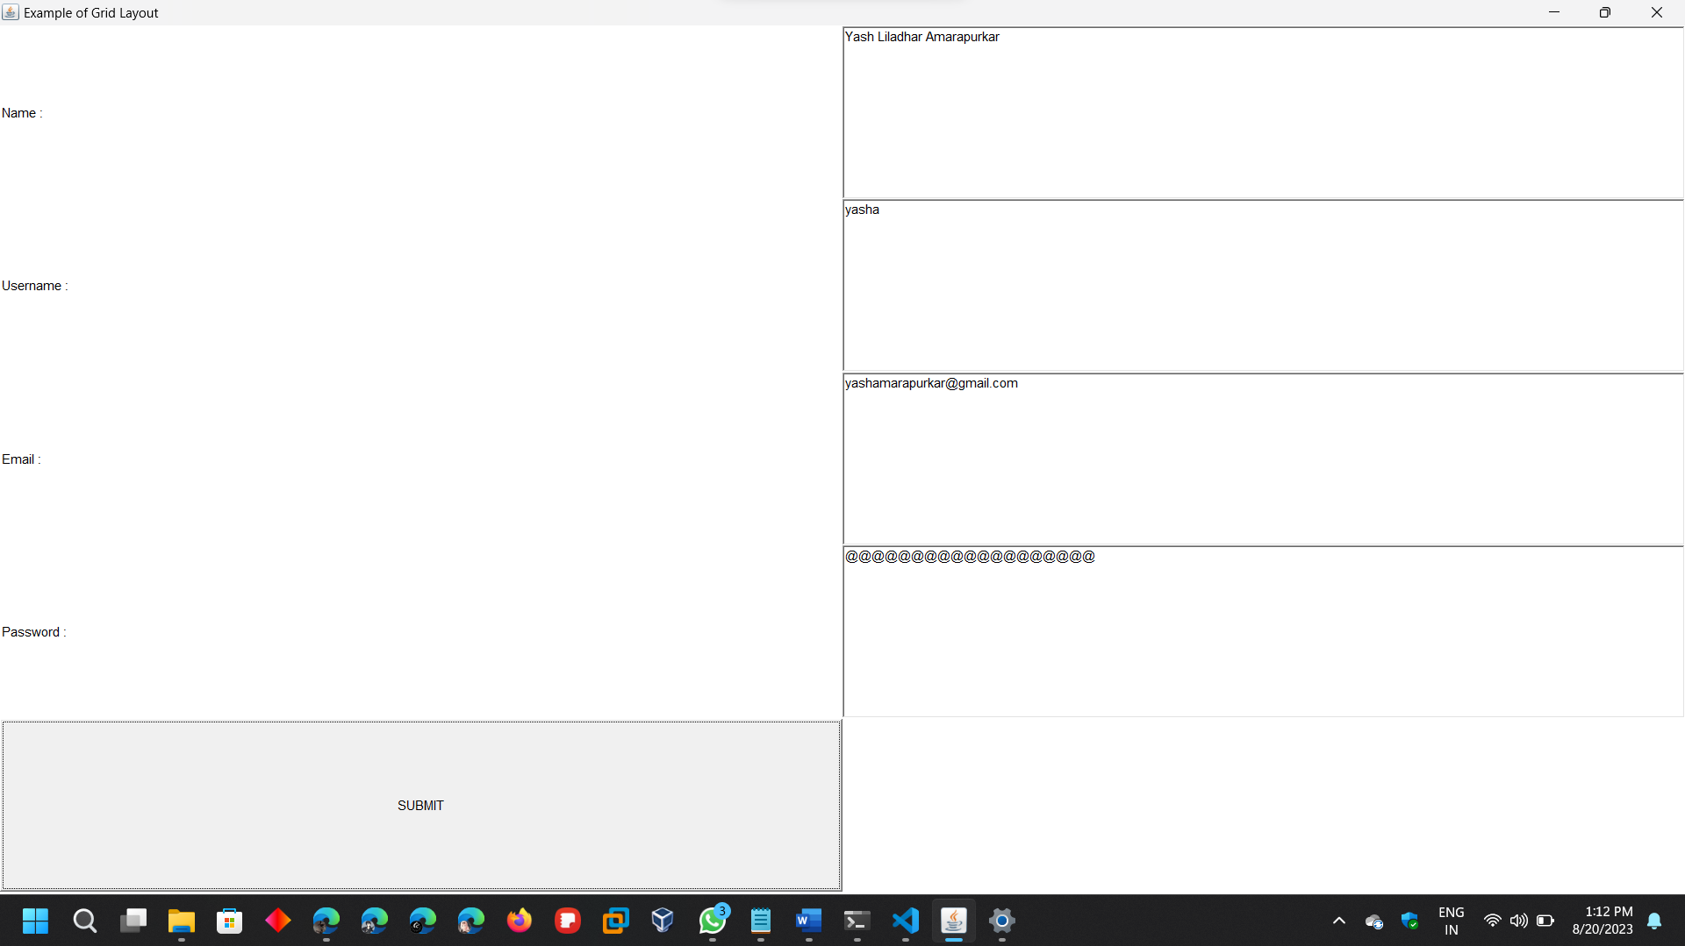

To Present given output :

import java.awt.\*;

public class gridbag extends Frame{

public gridbag()

{

setVisible(true);

setSize(300, 300);

setTitle("GridBag Layout Example");

GridBagLayout grid = new GridBagLayout();

GridBagConstraints gbc = new GridBagConstraints();

setLayout(grid);

GridBagLayout layout = new GridBagLayout();

this.setLayout(layout);

gbc.gridx = 0;

gbc.gridy = 0;

this.add(new Button("Button One"), gbc);

gbc.gridx = 1;

gbc.gridy = 0;

this.add(new Button("Button two"), gbc);

gbc.gridx = 0;

gbc.gridy = 1;

this.add(new Button("Button Three"), gbc);

gbc.gridx = 1;

gbc.gridy = 1;

this.add(new Button("Button Four"), gbc);

}

public static void main(String[] args) {

new gridbag();

}

}

